Success Academy, District 4232

2021 - 2022 School Year Read Well by Third Grade Plan

As written by Minnesota Statute 120B.11, a Minnesota school district must adopt a local literacy plan to have every student reading at or above grade level by the end of third
grade. The local literacy plan must have a process to assess students’ level of proficiency, notify and consult with parents, and intervene with students who are not reading at or above grade level. In addition, the district must have a staff development plan to assist students in meeting these goals. The district must also post its literacy plan on its public website.

Reading well by third grade is one of many developmental milestones in a child's educational experience. Literacy development starts at an early age and is the basis for academic success. Reading well by third grade ensures that a student has a solid foundation of literacy skills to continue to expand their understanding of what they read, make meaning, and transfer that learning across all subject areas. Instruction that provides the basis for all students to read well by third grade and beyond will help close the achievement gap and ensure that all students are ready for the demands of college and the workplace.

What is the purpose of this plan?

The purpose of the literacy plan is to provide an overview of how our staff will continually work to improve the academic achievement of all students by identifying needs, implement research- based instruction, engage in on-going professional development to improve the practice of teaching and involve parents and the community in a partnership to meet the needs of our students.

This plan will develop over time.

What are our literacy plan goals?

- All students who are not meeting grade level expectations will be provided support to close the gap of achievement and reach grade level.
- All students who are exceeding grade level will be provided instruction to challenge them and increase their learning.
- All stakeholders in the district will be informed of the efforts to ensure all of our students will be reading "well" by third grade.

How will we know if our students are reading well by third grade?

- Our students in grades K-3 will be assessed ongoing using the AIMSWEB reading assessment program. Reading proficiency will be defined as reading at or above benchmark and who perform at grade as defined by AIMSWEB benchmarking level in the
classroom. Reading proficiency will be ensured for all students in kindergarten through grade three by multiple measures of assessment, data driven instruction and a response to intervention approach to build literacy skills. Students not reading at grade level will receive support, intervention and progress monitoring until proficiency is
attained. Interventions will supplement not supplant reading instruction.

- For the 21-22 school year Success Academy worked with Reading Corp to address student reading deficiencies. Two interventionists work with students
identified by data as needing “learning to read” assistance. The interventionists work with each child three times a week in grade K-3 and are progress monitored regularly within the program. Interventions are ongoing until the student shows data points above the average for growth within the program. Success Academy Bloomington was served by the Americorp Reading Corp for the full school year. Success Academy St. Cloud was served by the Americorp Reading Corp for ½ of the school year due to staffing issues.

- For the 21 -22 school year Success Academy joined the Groves Literacy Initiative for grades K – 3. Within this program our teachers will be using a researched based reading curriculum, be observed weekly by a master reading teacher, and have ongoing professional learning through the Groves Literacy Initiative. Both the Bloomington and St. Cloud campuses were involved in Groves Literacy. St. Cloud will join in grade 3 will join the program for the 22 – 23 school year.

- The school is also engaging in NWEA / MAP assessments for all students in grades K – 3. We are assessing students in fall, winter and spring using this test and teachers receive feedback immediately once the tests are completed as to student progress.

- Teachers are engaging in bi-weekly assessments in reading comprehension and vocabulary to have current data with which to do instructional planning.

What kind of assessments will be used and when?

All students participate in the MAP / NWEA assessments by October 1, 2021. Students were also assessed in both the fall, winter and spring for growth comparison.

In addition, all students in grades K- 2 were benchmarked in AIMSWEB by September 30, 2021. Students in grade 3 will be benchmarked in MAP Reading Fluency by September 30, 2021. Teachers will be able to begin to schedule interventions for Tier II and Tier III students after the initial benchmarking. There was ongoing progress monitoring for Tier II and Tier III students throughout the year. The second AIMSWEB / MAP Reading Fluency benchmarking in January, 2022 as well as a third in April, 2022 that will help determine growth. We will use the MAP Reading Fluency tools to develop a more comprehensive view of each student and their progress.

MCA III testing will be completed as scheduled in the spring of 2022 for students in grade 3.

District screen, Kindergarten: Self-made assessments in: Phonemic awareness, letter naming, and letter sound correspondence. AIMSWEB assessments in: Letter naming fluency, letter sound fluency, oral reading fluency.

District screen, Grade 1: Self-made assessments in: Concepts of print, high frequency / site words, vocabulary, comprehension, teacher running record of student’s fluency and comprehension quizzes. AIMSWEB assessments in: Oral reading fluency

District screen, Grade 2: Self-made assessments in: Oral language development, high frequency / site words. Assessments for each ELA standard, given and monitored by the teacher. Journeys assessments in: Phonics / decoding, vocabulary, comprehension. AIMSWEB assessments in: Oral reading fluency, vocabulary and reading comprehension.

District screen, Grade 3: Self-made assessments in: Phonemic awareness, letter sound correspondence, high frequency / site words, vocabulary. AIMSWEB benchmarking, NWEA assessment in: Oral reading fluency and reading comprehension

What norms will be used to inform us of how students are doing?

We will use the AIMSWEB benchmarking from fall, winter and spring to help us determine student growth in reading. In addition, we will use the NWEA outcomes from fall to spring to give us information on how the students have grown this year.

How will parents be informed if their child is not reading with proficiency?

- Teachers will report student diagnostic and progress monitoring to parents at fall and spring conferences.

- Parents will be invited to a literacy session where there will be information on how to improve their students' reading skills. Staff will also send parent newsletters with literacy tips for families.

- Grades are reported quarterly, will indicate the areas of need and whether students are reading at grade level.

- Parents will be notified when students are participating in additional pull out reading support through Reading Corp.

What instructional supports and interventions will be used?

Intervention programs provide support for students who are struggling with literacy. Based on diagnostic assessments and teacher observation students will receive multi-tiered levels of
intervention support that is based on researched based interventions. These interventions provide support in the areas of phonics, comprehension, vocabulary and fluency.

Tiers of support:

Tier 1: Core in-class instruction

All students receive core in-class instruction. The school will use the Daily 5 plan to develop literacy skills in all students. Students who are at or above the benchmark as indicated by AIMSWEB and NWEA fall testing and making sufficient academic growth will have their needs met in the core in-class instruction. Students who are below or significantly above grade level benchmarks will receive additional reading services on top of regular instruction in Tier 2 or Tier 3.

Students have a 120 minute consecutive block each day and an additional 30 minute block in reading each day. (Total of 120 minutes of literacy instruction each day.) In addition, the schedule includes a 30 minute “WIN” (what I need) time for reading Mondays through Thursdays.

For students in grades K – 3 Success Academy Charter School will use a researched based curriculum in coordination with the Groves Literacy Initiative.

For grade 3, Success Academy Charter School Bloomington uses the Journeys curriculum, which is aligned with Minnesota standards. Success Academy St. Cloud uses the Into Reading curriculum which is aligned with Minnesota standards.

Tier 2: Extra support

Students who are below grade level through classroom small group and individual instruction. This instruction is based on AIMSWEB and Map Reading Fluency screening as well as NWEA testing. AIMSWEB and MAP Reading Fluency benchmarking will happen three times as well NWEA testing so students who improve have a chance to exit Tier II or Tier III. Additional support is provided during a schedule block or "response" time. To gauge the effectiveness of instruction, staff progress monitors students through the AIMSWEB and MAP Reading Fluency program.

Students scoring in the "green" level: Progress monitoring done monthly Students scoring in the "yellow" level: Progress monitoring three times a month Students scoring in the "red" level: Progress monitoring weekly

If students score above their goal three to five consecutive times, including once above the benchmark score, this intervention may be discontinued. However, teachers will continue monitoring progress to ensure mastery.
Instructional supports can include:

-Students who are in need of added support can be part of the Reading Corp intervention program at Success Academy. Students receive pull out instruction IN ADDITION to grade level instruction three times a week. Students in the St. Cloud campus who are in need of extra support also are targeted for intervention though a part time interventionist and as well as locally trained tutors.

-Researched based interventions based on the desired skill.

-Added time to reinforce taught skills. All students receive grade level instruction and then additional support as needed. This is done through our “WIN” (what I need) support time for reading, each day Monday through Thursday.

-Small group instruction supported by paraprofessional support within the classroom. Depending on size of group, the teacher may do the intervention group and a support person will work with the students that need more challenge in the class.

Tier 3: Intensive support

Students who are significantly below grade level are supported by programming and instruction that may occur outside the classroom. Interventions are performed by trained staff three to five times per week. To gauge the effectiveness of interventions staff will progress monitor students using the MAP Reading Fluency program. Students who score above their goal three to give consecutive times, including one above their benchmark score may have their intervention reduced or discontinued. However, teachers will continue to monitor progress to ensure mastery. We will have intervention time that is in ADDITION to the general curriculum time in reading each day.

Intervention programs may include:

- After school tutoring with teachers
- Weekend tutoring with teachers
- Reading Corp support
- Interventionist work (St. Cloud campus)
- Moby Max online work
- Referral to the problem-solving team to discuss pre-special education referral interventions
- Depending on intervention outcomes, possible special education referral

What supports are in place for ELL students?

The school employs a full time ELL teacher who will administer ACCESS testing for all
students. The ELL teacher will do a professional development program that focuses on the "can do" indicators so that staff will have an idea about what students are capable of doing. For those students that score lower level ACCESS scores, the ELL teacher will work with all classroom teachers to help design programming for higher need students. The ELL teacher works with the students by pushing-in for whole group work multiple times each week. The ELL teacher may pull students that need intensive or extra support as needed. For 22 23 school year both schools will seek to hire a 2nd EL teacher at each building.

How will the district screen students for dyslexia?

Screening: The district makes an effort to screen and identify students with dyslexia and students with convergence insufficiency disorder by using the Shaywitz Dyslexia Screener for those students in grades K-2 through AIMSWEB. Parents are contacted and encouraged to bring their child to their pediatrician if the student “flags” for dyslexia. In addition, these findings are taking into account when the school has problem solving meetings regarding student progress.

Dyslexia is a learning disorder characterized by difficulty reading due to problems identifying speech sounds and learning how they relate to letters and words. Also called specific reading disability, dyslexia is a common learning disability in children.

Symptoms:

A person with dyslexia may have a hard time with:
  - Identifying words
  - Recognizing the sounds that make up words
  - Understanding and remembering what is read
  - Translating printed words into spoken words
  - Spelling
  - Organizing or sequencing thoughts
  - Rhyming words
  - Learning the alphabet and numbers during preschool and kindergarten

If a student scores below benchmark on the school’s reading screening, a dyslexia specific screening assessment will be administered. Parents may also request a dyslexia specific screening if they have concerns.

During the 2021 - 2022 school year the Success Academy screened students in grades K-2 using the Shaywitz dyslexia screener. The school screened 20 students over the course of the year. One student was referred via their parents to a pediatrician for more study.

How will the district screen students for convergence insufficiency disorder?

Convergence insufficiency Disorder is a common eye muscle co‐ordination problem in which the eyes have a strong tendency to drift outward when reading or doing close work.

Symptoms:

Signs and symptoms occur while you're reading or doing other close work and may include:
  - Eyestrain
  - Headaches
  - Difficulty reading - words blur or seem to move on the page
  - Double vision
  - Difficulty concentrating
  - Squinting or closing one eye

The district will provide professional learning around dyslexia and convergence insufficiency disorder during the fall, 2022 workshops and again if we have new staff members that join the staff during the school year.

What opportunities do teachers have for professional development?

Professional development is inclusive for all teachers at Success Academy. It is delivered in a variety of formats and is aligned to district and school goals.

- There are 17 professional development days for all teaching and support staff.

- Students are dismissed each Friday at 11:30 AM, allowing for teachers to meet weekly in Professional Learning Communities to review student progress, collaborate on instructional practice and to build skills on Minnesota academic standards.

- The focus of staff training for 21 - 22 was to continue to develop skills in identifying strategies for comprehension (both reading and math) as well as vocabulary building for all learners. Staff will continue to work collaboratively to define mastery of the standards and to review student work to discuss student progress in relation to comprehension and vocabulary.

- Administrators will use formal and informal evaluations to assist teachers in developing their overall practice.
- Staff input will be taken throughout the year by survey to gain insight into teacher needs for professional learning.

- Each teacher will have three formal classroom observations with pre-meetings and post meetings. All staff have been given and trained in the observation tool.

What is our plan to report our annual student data and report to our stakeholders for feedback?

Spring AIMSWEB and NWEA data will be reported to the Commissioner of the Department of Education. Data will include students who are proficient in K, 1 and 2.

Success Academy Charter School's Read Well by Third Grade plan will be posted to our school website by June 30 each year. A survey will be accessible through the web page where stakeholders can provide feedback on:

-Accessibility of information
-Usefulness of information
-Support for implementation of strategies at home

Next steps:

During the 2021 - 2022 school year Success Academy Charter School continued to work at improving the academic skills of all of our students. We will critically review our Read Well by Third Grade and Literacy plan and make changes to address the needs of all of our
students. We will analyze data to assist us in developing our strategies. We will use our data and staff input to develop our staff training plan. Through a staff survey we have determined that our staff learning priorities are comprehension and vocabulary across the curriculum. This includes both academic vocabulary as well as content specific vocabulary. The comprehension indicator includes all subject areas, but more specifically mathematics where many EL learners struggle with proper nouns and making sense of number problems.

DATA REVIEW FROM 2021 - 2022 SCHOOL YEAR ASSESSMENT USED IN GRADES K – 3: NWEA Reading

NUMBER OF STUDENTS Students meeting reading growth goals from Fall, 2021 to Spring 2022:

GRADE K - 29 13 of 29 (45%)
GRADE 1 - 41 25 of 41 (61%)
GRADE 2 - 31 17 of 31 (55%)
GRADE 3 – 37 19 of 37 (51%)

Groves Literacy Data – St. Cloud:
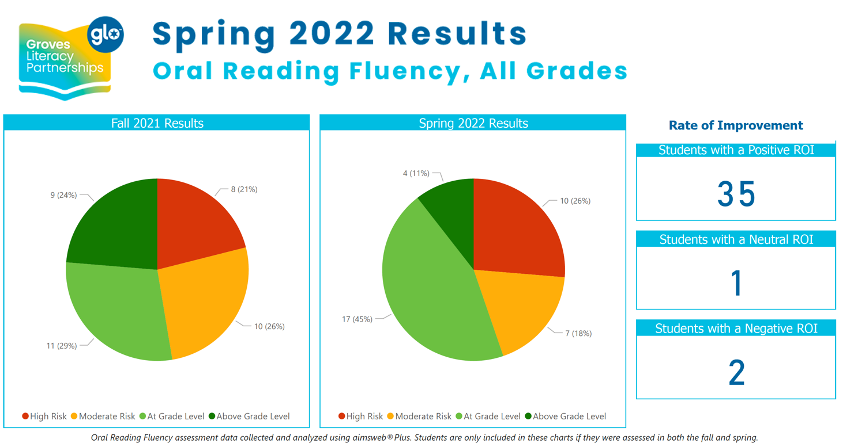

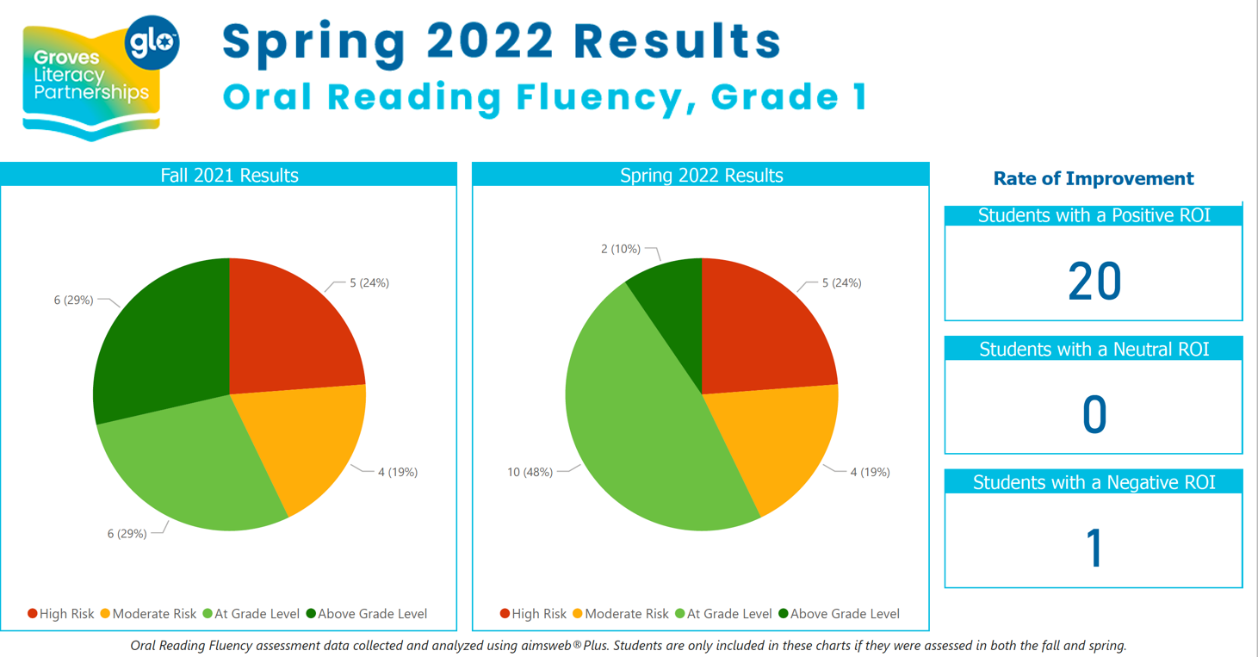

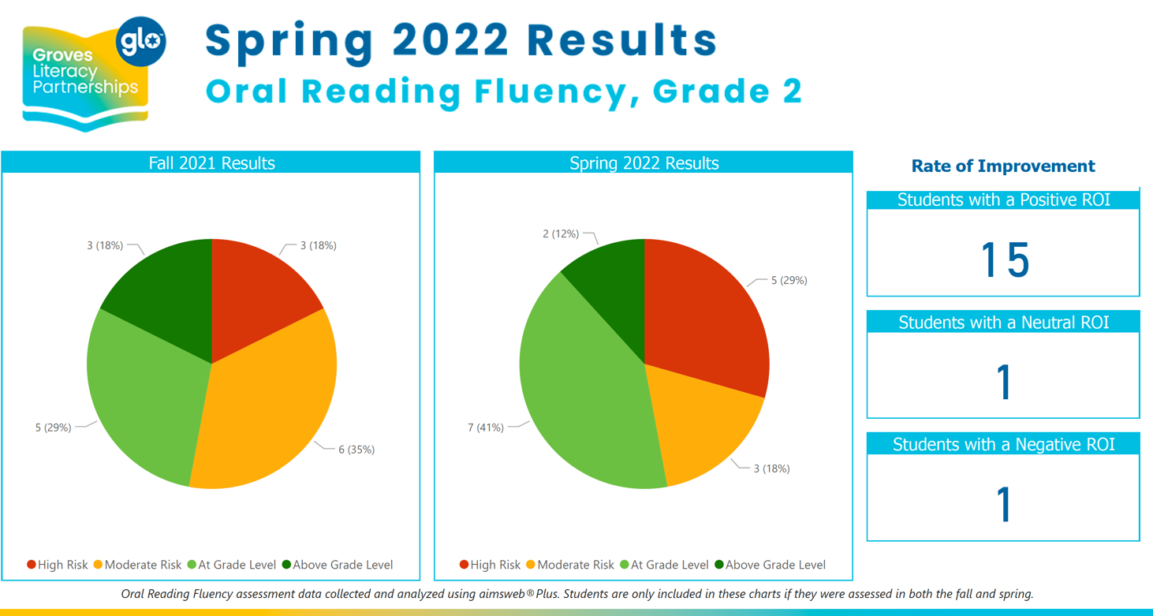

Groves Literacy Data: Bloomington

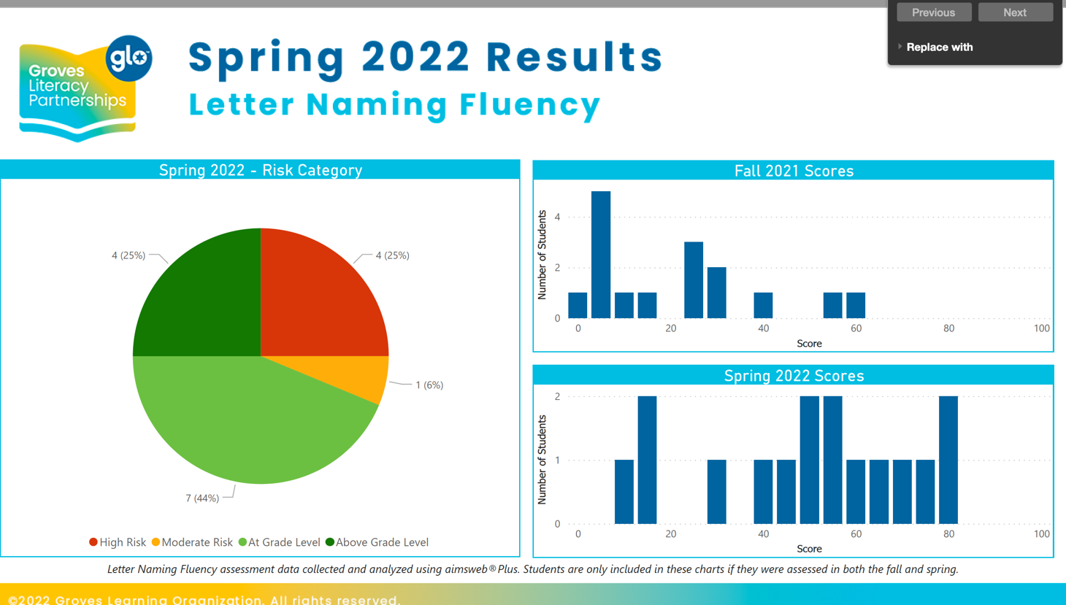

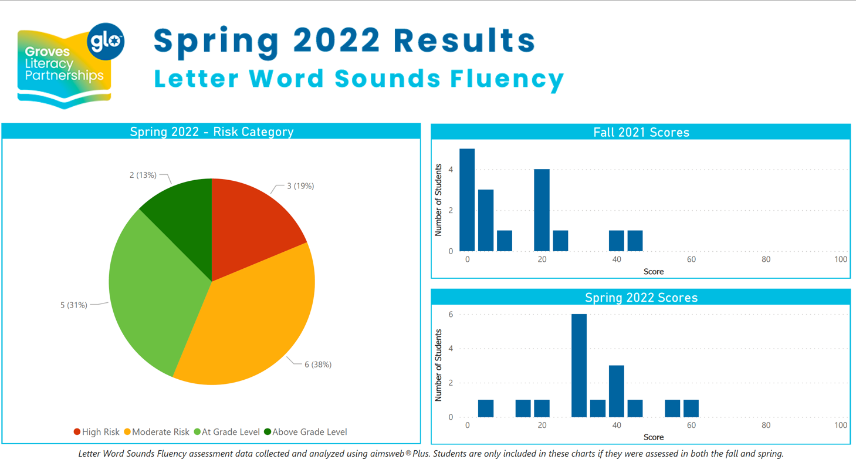

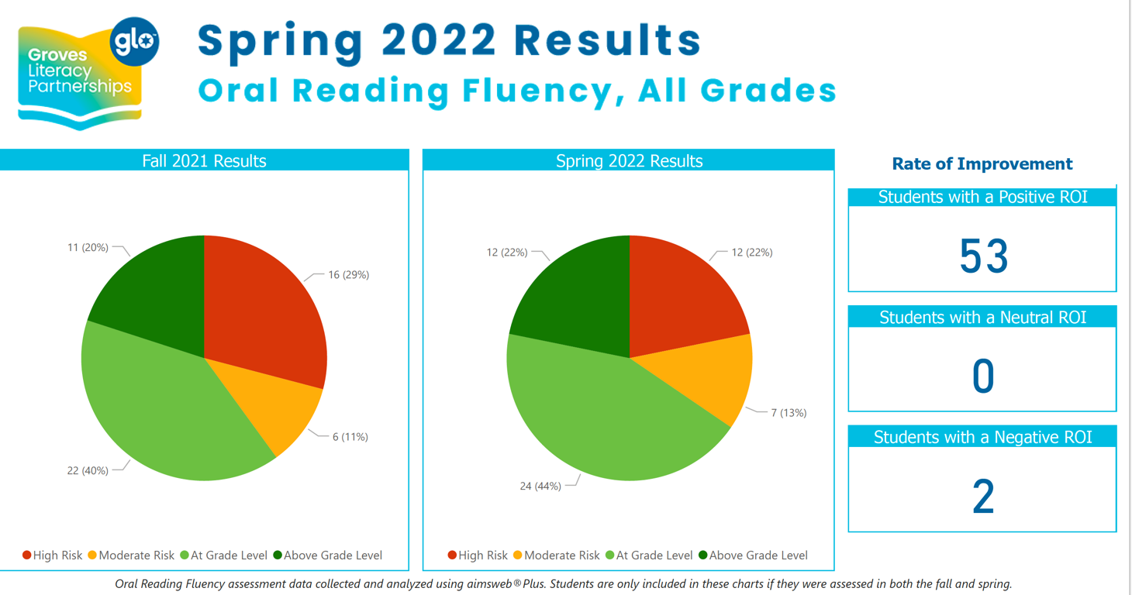

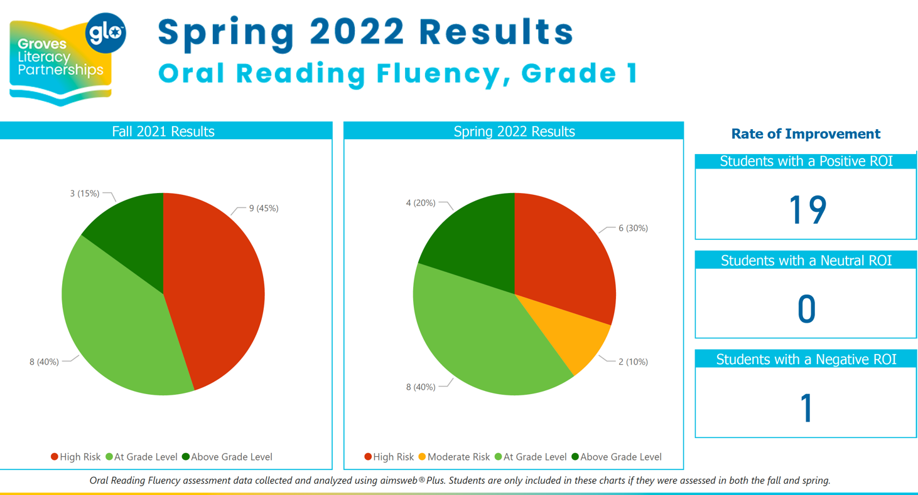

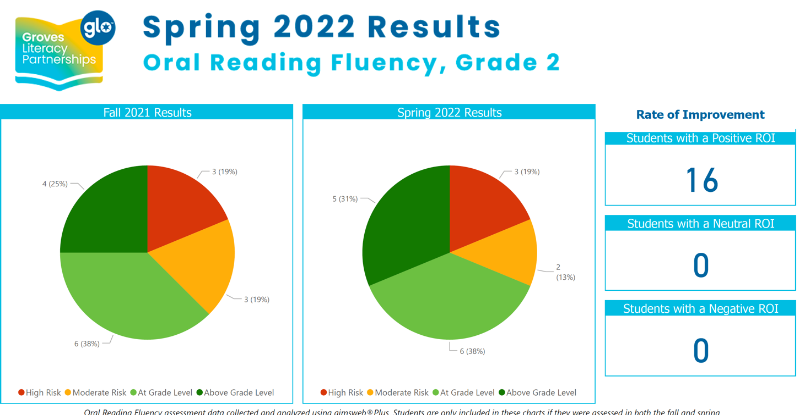

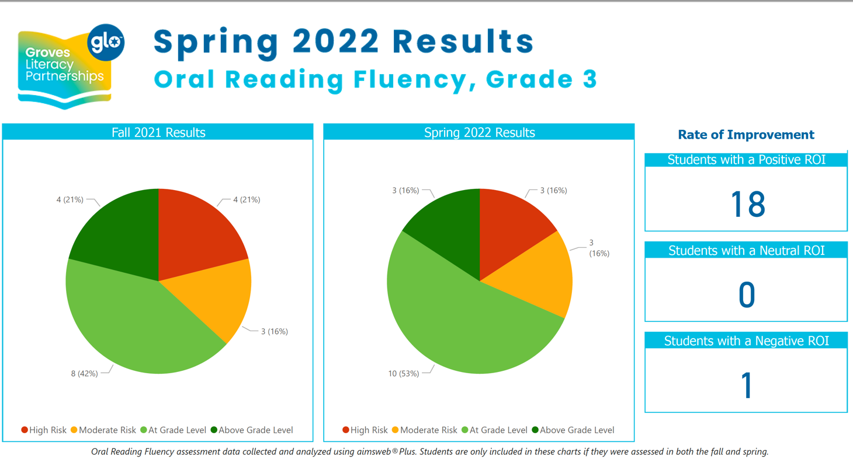

Cultural diversity at Success Academy

Success Academy campuses have between 65% and 85% of English Language Learners. These challenges impact all instruction across all subjects. Based on ACCESS testing scores and the WIDA screener completed by the district’s EL teachers, the schools design an EL program to work to meet the needs of the students.

As the EL teacher works with classroom teachers, the school’s use a mix of push in and pull out programming, depending on the needs of students. During the 2020 - 2021 school year in Bloomington, the EL teacher used a deliberate planning process with each classroom teacher to assist students. Sometimes, there was emphasis on math vocabulary building, sometimes there was phonics instruction. But the key is the deliberate planning process.

Post assessment methods and data management

Teachers in the K - 3 grades do an early assessment of student needs using student records as well as teacher made assessments. Teachers collaborate together and with the Director of Instruction about data interpretation and next steps. Each teacher at Success Academy has a full 2 hours inservice at the start of their time in the district to look at how to evaluate data across the classroom, the standards, the individual student responses and individual student responses to specific assessment items.

Literacy items for K - 3 grade levels

Grade K ABC names ABC sounds
Concepts of print (holding a book correctly, reading left to right) Phonemic awareness
Sight words Story sequencing
Writing name correctly
Words, syllables, sounds - beginning, middle, end

Grade 1
Letter naming fluency Sight word fluency
Story components - characters CVC words
High frequency words Nouns
Verbs
Sentence writing - developing paragraphs of three sentences

Grade 2
100 high frequency words Fluency measurements Comprehension
Writing development to include two presentations

Grade 3 Reading fluency Noun / verb sort
Writing development to include multiple presentations and peer review Vocabulary through context
Sequencing Summarizing
Fiction / non fiction writing and reading

